3.3 Development Methodology

3.3.1 Process Model

The waterfall methodology is a linear project management strategy in which client requirements are gathered at the start of the project, and a sequential project plan is then built to satisfy those requirements. The waterfall model gets its name from the way each phase of the project cascades into the next, like a waterfall.

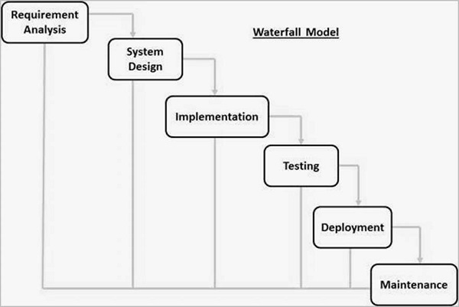

**Figure 1: Process Model – Waterfall Development Methodology**

This model consists of 6 phases which are requirement analysis, system design, implementation, testing, deployment, and maintenance. All of these phases are connected in a cascade, with progress appearing to flow smoothly downwards (like a waterfall) through them. The following phase begins only after the preceding phase's established set of goals has been met and it has been signed off.

3.3.2 Development Tools

|  |  |
| --- | --- |
| **Programming Languages** | JavaScript (Client Side)  PHP (Server Side) |
| **Relational Database Management System** | MySQL |
| **Integrated Development Environment (IDE)** | Visual Studio Code |
| **Framework and Library** | Bootstrap (Front End Framework)  Wkhtmltopdf for PDF Generation |
| **Application Programming Interface (API)** |  |
| **Server (Local Web Server for Testing)** | Cross-Platform (X), Apache (A), MariaDB (M), PHP (P), and Perl (P) |
| **Web Browser** | Google Chrome |

3.4 **Test Methodology/Procedure**

The test methodology plan lays out the approach for verifying and ensuring that the system meets the design specifications and other requirements. It is prepared by the testers or with significant input from them. This will guarantee that the system meets the client's requirements.

The following are the tests that the system will undergo:

* System Testing – This test will check if the system is functional in different browsers
* Acceptance Testing - This test will ensure that the system meets the requirements of the client.
* Functional Testing – This will show if the system output meets the requirements of the client
* End-to-end Testing – This is to test the functionality and performance of an application under product-like circumstances to replicate live settings.

3.5 **System Requirements**

3.5.1 **Hardware Requirements**

Both the faculty researcher and the dean/chairperson must have a desktop or laptop to access the system.

|  |  |
| --- | --- |
| **Hardware Component** | **Minimum Specification** |
| Processor | Intel i3-2330 Processor 2.20 GHz |
| Installed Memory (RAM) | 4.00 GB |
| Hard Disk Drive | 500GB |

3.5.1 **Software Requirements**

|  |  |
| --- | --- |
| **Software Component** | **Minimum Specification** |
| Microsoft Windows 10 | 64-bit |
| XAMPP | **7.1.32-0 / 7.2.22-0 / 7.3.9-0** |

Operating System

* The suggested operating system is at least Windows 7 64-bit or higher.
* To manage the database of the system, the following software are needed
  + MySQL
  + phpMyAdmin

Browser

To access the website, any updated browser can be used. Google Chrome is a highly suggested platform that ensures full interface functionality.

Other Software needed

To be able to fully utilize the functions of the system, the clients are recommended to install the following:

* PDF Viewer
* Printer